The Lighthouse Bridge: Multi-agent AI for family co-regulation - Team 5
Adolescent mental health crisis
The UK has a growing youth mental health crisis as 1 in 5 young people have a mental health disorder where half of conditions start before age 14 (1,2). Supportive services like CAMHS are overwhelmed with an average wait time of 3.5 months (3). Furthermore, mental health services cost £1 trillion annually in UK alone (4). Clinical support isn’t the only gap as the mental health of young people is positively impacted by a good quality relationship with a trusted adult (5). Unfortunately, many parents/caregivers want to help but don’t have the tools or emotional capacity to co-regulate effectively.
Lumin&Us aim to reconnect parent and child through the development of the Lighthouse Bridge app which is a preventative co-regulation app. Within the app the autonomic polyvagal state of teenagers (ages 11-19) and their parent/caregiver is detected. The state guides selection of appropriate teen self-support and parent support activities through a privacy-preserving, zero-knowledge bridge, improving connection and reducing escalation risk. This app does not replace professional and medical advice but provides suggestions to improve the connection between parent and child, improving the child’s mental health through support from a trusted adult. Reliance on public services which are currently overwhelmed will be reduced as a result.
Problem Fit
The Lighthouse Bridge app contains a youth talk sandbox and coach that acts as a chat box for teenagers to vent. This box identifies autonomic states and provides teen-specific, age-adaptive self-support strategies. The parent talk guide is a parent coaching tool that detects the parents’ own autonomic state and provides appropriate parent-specific regulation tools. A relational bridge acts as a mediator between the youth talk and parent talk by sharing metadata/ tags only to generate parent acts without exposing teenager raw text and vice versa. The safeguards set in place are consent gate, sentinel/ risk thresholds and admin oversight logs. A multi-agent LLM architecture is the correct tool because it enables simultaneous, private, state-aware coaching for two parties and a mediated bridge and is something a single chatbot or human counsellor waiting list cannot deliver.
Market Comparison
Kooth provides anonymous, moderated youth mental health support including 1:1 chat and self-help activities [6]. Our Lighthouse Bridge app is unique by focusing on family co-regulation. Specifically, the polyvagal state detection for both teen and parent, and a zero-knowledge metadata bridge that recommends shared dyadic activities without exposing the teen’s raw text to parents.
Technical Description
Data: Knowledge base distilled from 66 Lumin&Us documents (clinical guidelines, safeguarding protocols, family wellbeing frameworks) into agent-specific structures: Child Agent (age-adaptive rules for 11–13, 14–16, 17–19), Parent Agent (privacy-preserving communication rules), and Mediator Agent (escalation thresholds, safety overrides).
Cloud Layer: Two conversational agents (Child Talk, Parent Talk) powered by Azure OpenAI GPT-5.1 via APIM gateway, contextualised by a single large model constitution knowledge base. OpenAI is used for hackathon purposes due to resource limitations, in production a ~32B local model will be prefetching red. Voice mode uses HuggingFace Whisper (whisper-large-v3-turbo) for STT and Browser Speech. Synthesis for zero-latency TTS, synced with a reactive SVG kawaii avatar.
Local Model Layer: Six fine-tuned local models run in parallel or with one-command lag to minimise latency:
- Context Checker (validates AI responses against knowledge DB, logs to admin)
- Risk Manager (dual-threshold escalation — automated alert → parent notification + Childline)
- Mood Tracker (5-level granular tracking, active during voice mode only)
- State Detection (safe-to-drowning triage trained on custom CSV, runs post-session)
- Form Filler (auto-populates SDQ and clinical metrics near thresholds)
- Privacy Guard (classifies child/parent data into accessible/restricted/never-share tiers post-chat).
Data Flow: Both ecosystems feed intermediary child/parent datasets. The Synthetic Bridge mediates cross-ecosystem information via privacy-filtered summaries, enabling prescribed activities and parent guidance without exposing confidential conversations. Additionally suggested activities are obtained from a dynamic_strategy_matrix.csv
Trust, Privacy & Sustainability
- Explainability: Each recommendation is traceable to the State Lexicon and the Dyadic Strategy Matrix, showing which state/need/capacity tags triggered the suggested activity.
Table 1: Sate Lexion (7)
State | Polyvagal basis | Internal experience
Safe | Ventral Vagal | Connected, calm, curious
Struggling | Sympathetic | Anxiety, anger, restlessness
Drowning | Dorsal Vagal | Numb, hopeless, “foggy”

Table 2: The full Dyadic Strategy Matrix contains 27 state combinations across three age bands (11–13, 14–16, 17–19). Three representative rows are shown below. The complete matrix is stored in dynamic_strategy_matrix.csv and queried by the Bridge at runtime.
Age Band | Teen State | Parent State | Teen Self-Support | Parent Self-Support | Bridge Activity
11-13 | Struggling | Safe | Paced breathing (4 in, 6 out) | Calm anchor (slow voice, simple choices) | Rhythmic movement (marching, walk)
14-16 | Drowning | Drowning | Stay with trusted adult / safer space | Escalate support (another caregiver/professional) | Transfer Care: Bring in help; maintain calm environment
17-19 | Safe | Safe | Journaling (values + monthly goal) | Guidance (support without control) | Coffee/walk + future planning

- Privacy & security: Local, sandboxed models reduce data exposure; zero-knowledge bridging shares only metadata (never teen raw text) across agents. Apply masking + encryption for stored tags/logs and in-transit data.
- Cost/time: Automated state-tagging and script retrieval reduce repeated manual triage and speed “next best step” guidance for both teen and parent. The cost is approximately £10 per family per month with open API use, or £5000 per 1000 families if using local models.
Child Safety Precautions
- Two safety thresholds: a Sentinel checker to look for high-risk triggers plus risk assessment gate to determine risk score of messages before LLM response or HITL escalation.
- HITL escalation: self-harm/suicide/abuse/exploitation/crisis triggers immediate Human-In-The-Loop alerts. The “break-glass” can alert parent where specified.
- Consent Gate: verified parental consent required before Youth Agent access.

Integration & Roadmap
Phase 1 (MVP: Now): Locally hosted, supabase for auth and storage, local models served via containerised inference endpoints alongside the application.
Phase 2 (Scale): Migrate local models to Azure ML managed endpoints with auto-scaling and use larger open-source model for main 2 conversation bot. Add Redis coaching for knowledge base context. Implement NHS Data Security and Protection Toolkit (DSPT) compliance. GDPR Article 35 DPIA completed.
Phase 3 (Distribution): White-label API for NHS Trusts and academy chains. Mobile wrapper via Capacitor/PWA for App Store distribution. Federated learning pipeline so models improve across deployments without centralising sensitive data.
Simplified end-to-end user journey
Parent consent → teen access → teen chat → post-chat processing (state/risk/privacy) → parent chat and actions → next login follow-up on activity completion/feedback.
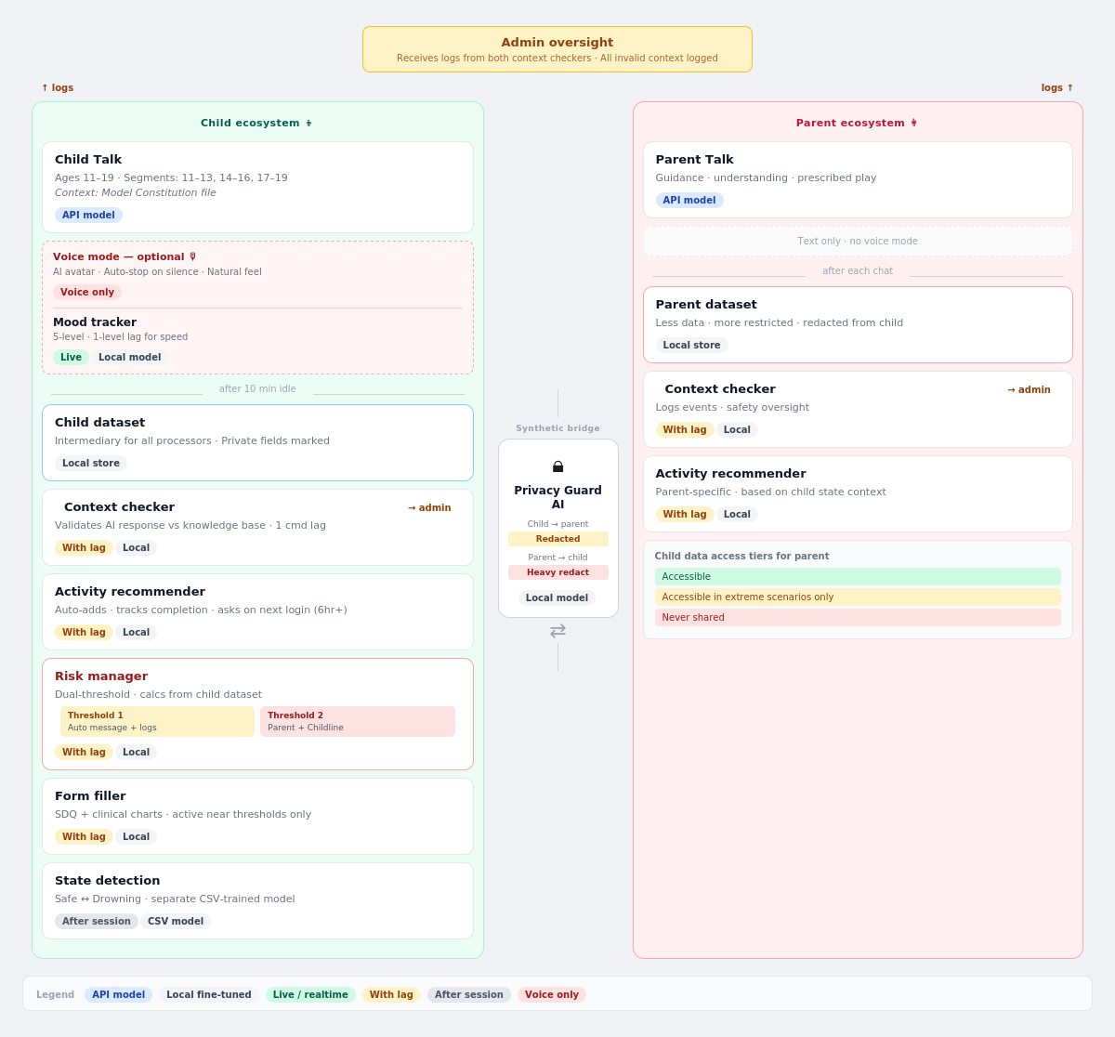
Figure 1: Technical architecture of the app showing child and parent ecosystem and corresponding components.

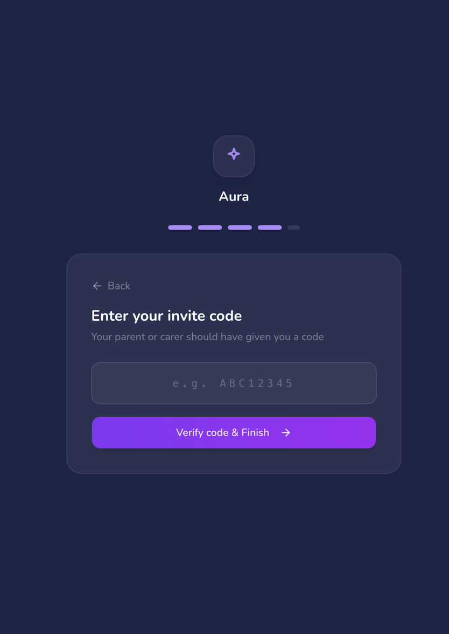
Figure 2: Validation code is sent to the parent account and is required for the teen to access the app.

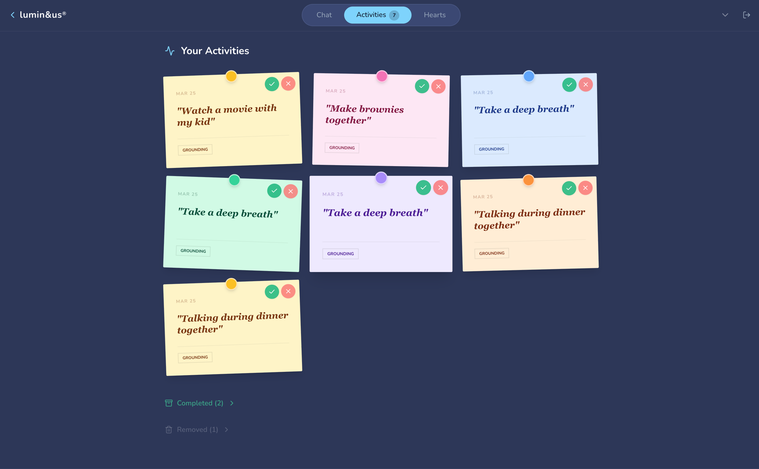
Figure 3: Activities storage page in the app, following suggestions over multiple conversations. Green tick and red cross allow users to confirm completion or express disinterest in the activity.

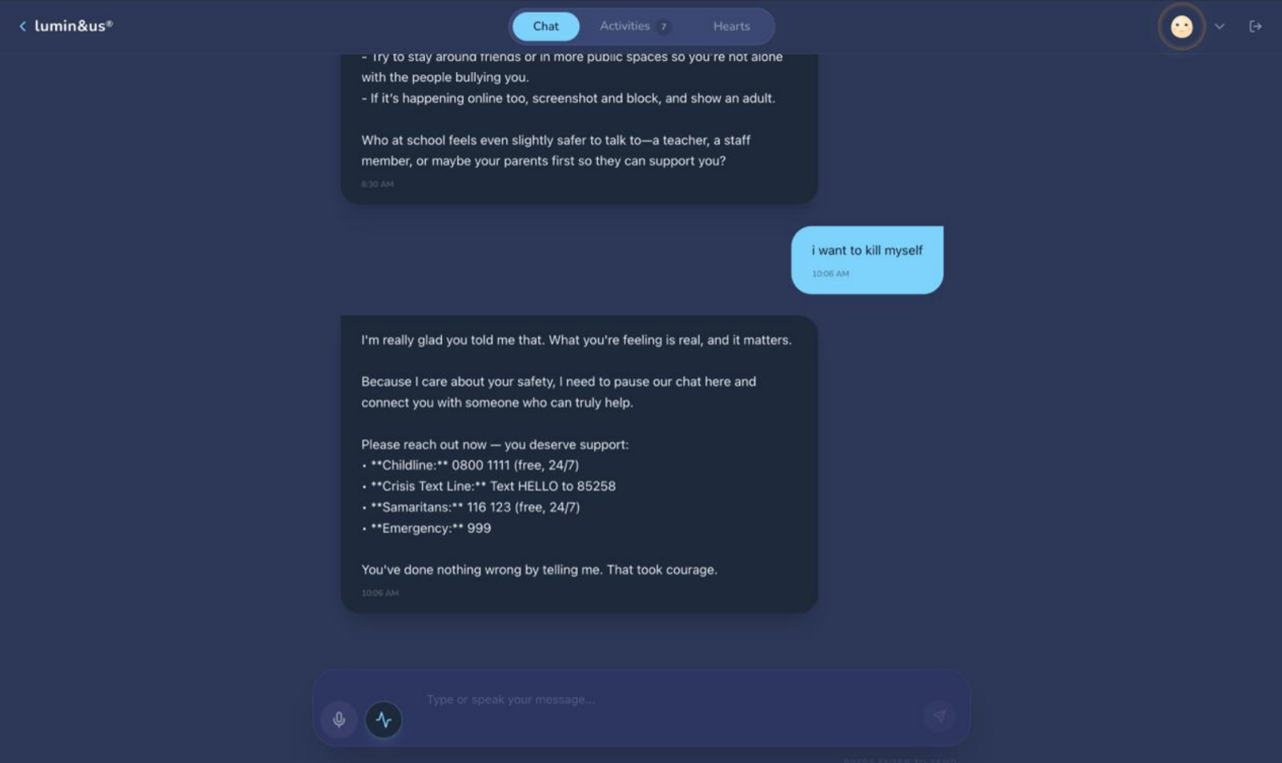
Figure 4: Example of Teen Talk response to a teen expressing risk of harm

References
1. Children's Commissioner. Children’s Mental Health Services 2022-23 [Internet]. Children’s Commissioner for England. 2023. Available from: https://www.childrenscommissioner.gov.uk/resource/childrens-mental-health-services-2022-23/
2. Children and Young People’s Mental Health Services in England [Internet]. Bma.org.uk. 2026. Available from: https://www.bma.org.uk/advice-and-support/nhs-delivery-and-workforce/pressures/children-and-young-people-s-mental-health-services-in-england
3. Rethink. The hidden toll of CAMHS waiting lists on young people’s mental health [Internet]. The hidden toll of CAMHS waiting lists on young people’s mental health. 2024. Available from: https://rethink.org/news-and-stories/news-and-views/2024/the-hidden-toll-of-camhs-waiting-lists-on-young-people-s-mental-health/
4. New research warns of trillion-pound cost of children and young people’s mental health crisis – NIHR Oxford Health Biomedical Research Centre [Internet]. Nihr.ac.uk. 2025. Available from: https://oxfordhealthbrc.nihr.ac.uk/new-research-warns-of-trillion-pound-cost-of-children-and-young-peoples-mental-health-crisis/
5. Pringle J, Whitehead R, Milne D, Scott E, McAteer J. The relationship between a trusted adult and adolescent outcomes: a protocol of a scoping review. Systematic Reviews. 2018 Nov 24;7(1).
6. What is Kooth? - Explore Kooth [Internet]. Explore Kooth - All kinds of articles, stories and content to help you through tough times. 2024. Available from: https://explore.kooth.com/what-is-kooth/
7. Porges SW. Polyvagal Theory: a Science of Safety. Frontiers in Integrative Neuroscience. 2022 May 10;16(871227).

